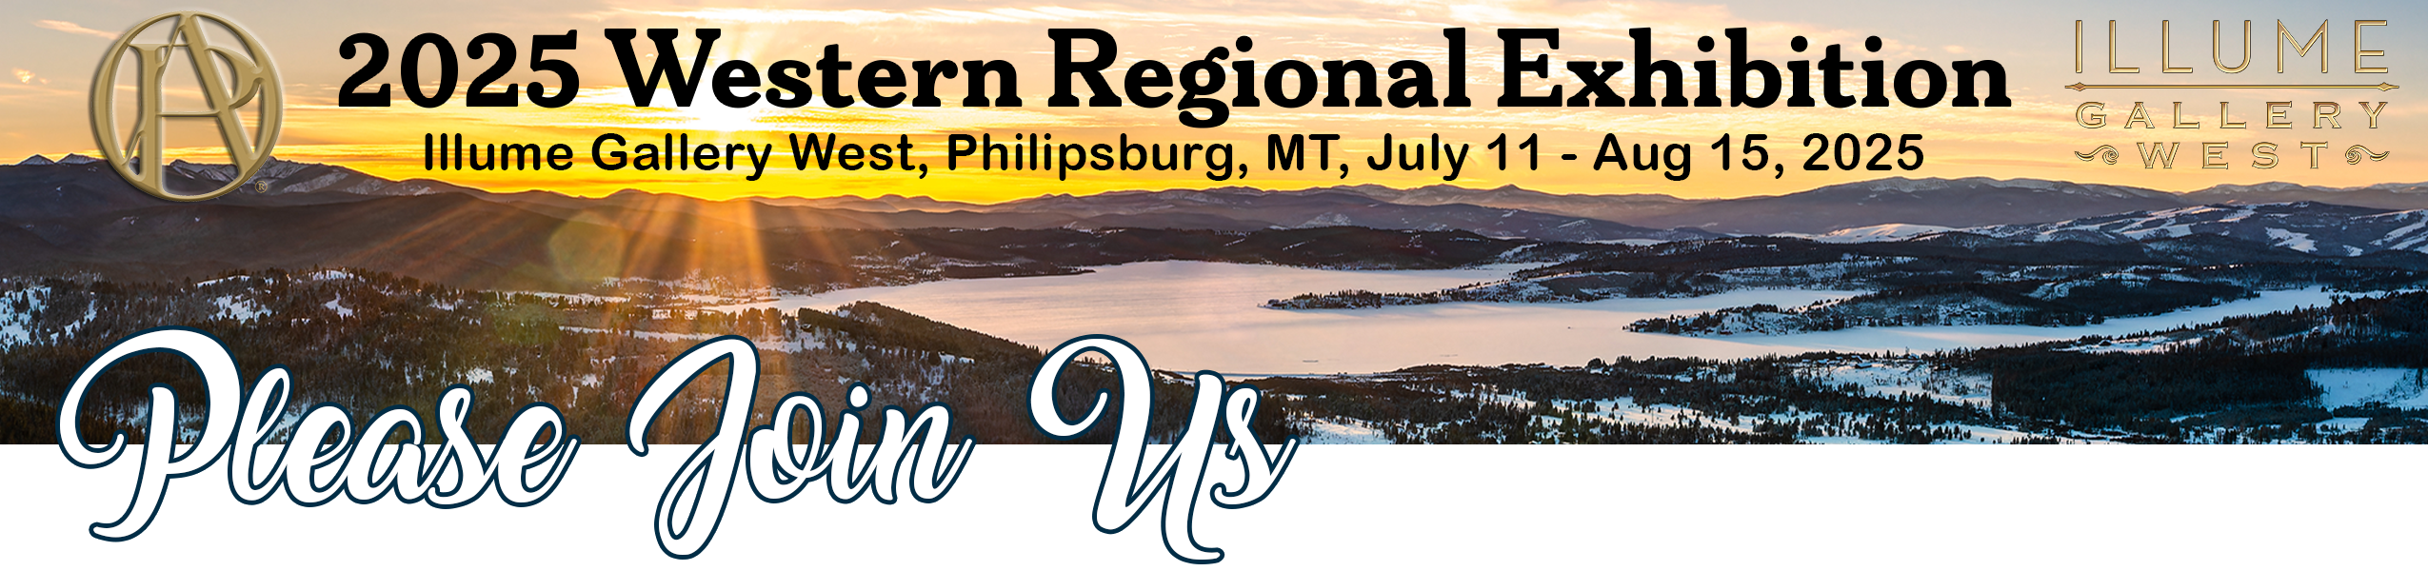



[www.oilpaintersofamerica.com](http://www.oilpaintersofamerica.com/)

@oilpaintersofamerica

**2025 Western Regional Exhibition Opening Reception**

**Illume Gallery West • Friday, July 11 • 5:30 – 9:00 pm**

Featuring the Artwork of

Name

*Title*, substrate, size, price

To request information regarding this artwork, contact

Illume Gallery West | 130 East Broadway Street | Philipsburg, MT

at 435.313.5008 or jane@illumegallerywest.com