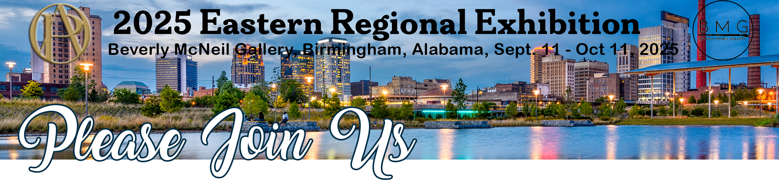
www.oilpaintersofamerica.com
@oilpaintersofamerica

2025 Eastern Regional Exhibition Opening Reception
Beverly McNeil Gallery • Thursday, September 11 • 5:00 – 7:00 pm

Featuring the Artwork of

Name

Title, substrate, size, price

To request information regarding this artwork, contact

Beverly McNeil Gallery | 605 28th Street South | Birmingham, AL
at 205.328.1761 or info@beverlymcneilgallery.com

